# УДК 004.891.2

***Колбеко А.Б***

*(научный руководитель д.т.н., профессор Глухих И.Н.)*

*Тюменский государственный университет, г. Тюмень*

e-mail: [stud0000108724@study.utmn.ru](mailto:eamez@yandex.ru)

# MATHEMATICAL MODELING OF THE STRUCTURE OF A TECHNOLOGICAL OBJECT BASED ON THE DESCRIPTION OF THE SUBJECT AREA

**Abstract**. This article discusses the issues of modeling the structure and parameters of complex technological objects, developing a system for modeling the structure based on the description of the subject area, and generalized programming.

**Keywords**: Formal representations, optimization, mathematical modeling, development.

The application of AI methods and digitalization of approaches to solving problems in the oil and gas industry is a relevant topic of discussion in the scientific and industrial community. The necessary conditions for solving existing problems using machine learning methods are the formalization of the initial data on the subject area, the identification of criteria and constraints of the problem from the list of requirements from stakeholders in natural language to a machine-readable form. This article is dedicated to the development of such a system and its practical application in oil and gas engineering, specifically in the search for optimal solutions in the selection of on-site facilities for the technological complex of production, collection, transportation, and preparation of oil and gas.

The effectiveness of machine learning methods and digital assistants using such approaches is unquestionable and is an actively developing field of science and engineering. For example, in the article [3], a system for detecting failures and decision support in well drilling was designed based on ontologies. Also noteworthy is the article [4], which describes a setup for preparing wood coal based on the principle of division into sections, each of which is characterized by some virtual parameter space and a parabolic differential equation. The authors note that such an approach is algorithmically complex and requires significant computational power.

When considering the conceptual design of a field at the early stages of project implementation, in conditions of high uncertainty, the use of software packages for modeling the raw material processing process in HYSYS or UNISIM is impractical. Currently, methods of cost engineering have been widely applied, such as the analogy method, which, however, does not allow for the uniqueness of the raw material composition and often leads to significant errors. At the same time, the task of configuring is solved at the level of determining the items of capital expenditures for the purchase of certain objects.

To solve such problems, an approach is proposed and the development of a software complex is underway, which allows:

1. Inputting data on the subject area

2. Establishing links between its components

3. Defining object attributes

4. Introducing constraints and criteria

The aim of the work is to develop an approach that allows reducing the conceptual design task to solving the optimization problem of the target installation's structure.

The software implementation of the domain editor is based on abstract entities that do not have a finite implementation. Configuring entities is based on data about the subject area obtained by transforming user input into an XML file.

Let a certain technological installation Ω include a set of objects:

|  |  |  |
| --- | --- | --- |
|  | $$A=\{a_{1},a_{2},a_{3}…a_{i}\}$$ | (1) |

Each object in set (1) has a set of categorical and numerical features:

|  |  |  |
| --- | --- | --- |
|  | $$B_{i}=\{b_{1},b_{2},b_{3}…b_{j}\}$$ | (2) |

For each feature (2), there is a set of values that the feature can take:

|  |  |  |
| --- | --- | --- |
|  | $$C_{ij}=\{c_{1},c_{2},c_{3}…c_{k}\}$$ | (3) |

The set of possible configurations in which an object from (1) can be found is defined as:

|  |  |  |
| --- | --- | --- |
|  |  | (4) |

If a set of relationships between objects E is defined for a set of objects A, then the technological installation Ω can be described by a graph:

|  |  |  |
| --- | --- | --- |
|  | $$Ω\left(V,E\right)=V,E>,VϵO_{n}$$ | (5) |

As an example, consider the representation of a water pre-flushing installation in the developed editor. The simplest diagram of the pre-flushing water installation is shown in Fig. 1.

The scheme includes the following equipment: C-1, C-2 - oil and gas separators (OGS), GS - gas separators; OG - horizontal settling tank; N-1, N-2 - centrifugal pumps. Flows: UKPG - high-pressure gas to the integrated gas treatment unit.

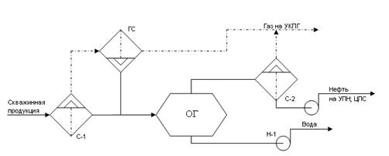

Рис. 1. Схема технологического объекта

To describe such a structure, it is necessary to introduce the data sets (1), (2), (3). The user interface, presented in Fig. 2, contains two main frames - the object frame and the attribute frame. The object frame includes input fields for name, attribute, and link. The attribute frame includes input fields for name, type, values, dimensionality and connections.

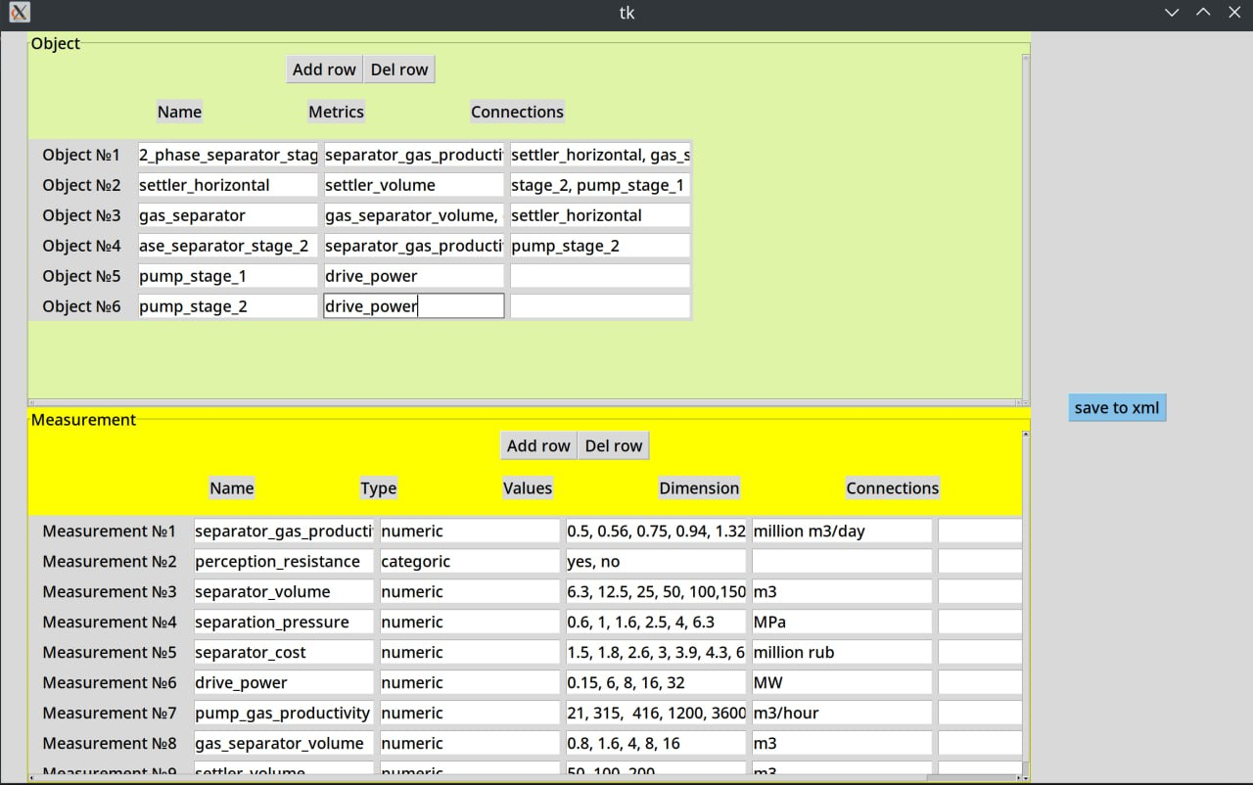

Рис. 2. Окно редактора

After editing the information about the modeled structure, the user can save the data to an XML file. The structure of the file and tags in this article are not considered due to space limitations.

At the current time, a software implementation is ready that serves as a structure generator (in accordance with (4)). In the future, it is planned to implement a module for editing optimization criteria, entering user constraints on the solution. Also, a discriminator will be required, which at each step of solving the problem will answer the question of whether the structure meets the criteria or not. The solver diagram is shown in Fig. 3.

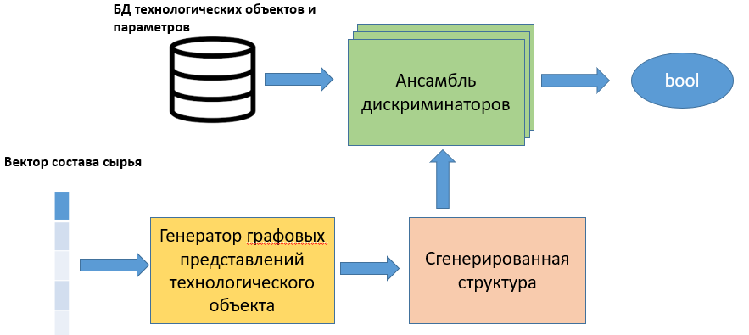

Рис. 3. Архитектура генеративно-состязательной сети

The approach described allows for describing structures of arbitrary technological objects. In the future, a discriminator module will be implemented. Training datasets for it in the considered domain will be obtained by performing series of calculations in the Hysys/Unisim software.

An alternative implementation of the discriminator could be a system that describes rules applied to objects. However, this development path is seen as undesirable because it will deprive the system of universality.

**Литература.**

1. Skalle, P. & Aamodt, Agnar. (2020). Petrol 18 946: Downhole failures revealed through ontology engineering. - Journal of Petroleum Science and Engineering. 191. 107188. 10.1016/j.petrol.2020.107188.
2. Mincho H., Nencho D. - Advanced Process Control of Distributed Parameter Plants by Integration First Principle Modeling and Case-Based Reasoning. - 2020 International Conference Automatics and Informatics (ICAI), pp.1-6, 2020.
3. HYSYS. Process. Версия 2.4. Руководство пользователя. Hyprotech. – 276 с.
4. Marsland, R.H. A User Guide on Process Integration for the Efficient Use of Energy, Insitution of Chemical Engineers. / Marsland, R.H - England, 1982 – 102 с.
5. M.T. Sowgath, S. Ahmed - Fault Detection of Brahmanbaria Gas Plant usingNeural Network - 8th International Conference on Electrical and Computer Engineering, IEEE, January 2015
6. Харари Фрэнк. Теория графов / Пер. с англ. В. П. Козырева. Под ред. Г. П. Гаврилова. Изд-е 2-е. М.: Едиториал УРСС, 2003. 296 с.: ил. ISBN 5-354-00301-6.